Here are some costume ideas – these pictures are for illustration and are only suggestions!
Grand Vizier 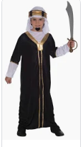
Genie 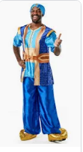

Ali Baba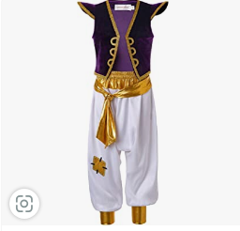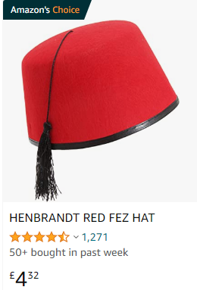
Princess Satsuma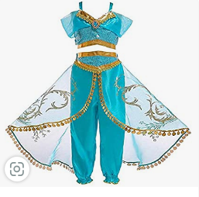
Hand Maidens – even black or black t-shirt (not quite as fancy as Satsuma) 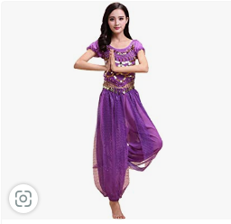
Sultan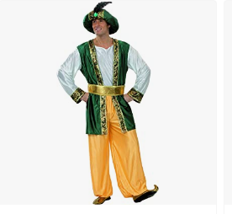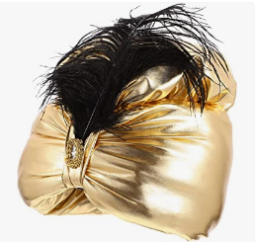

Flossy – Yellow dress (Arabian style is possible)

Izzi, Wazzi and Azzi – Black hareem pants, white t-shirt and a waist coat.

Boys/Traders and citizens - hareem trousers, tshirt and waist coat
Female Traders and citizens and Alakazam something similar but sparklier, girlier to the hand maidens
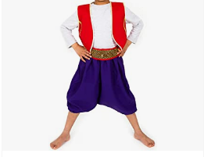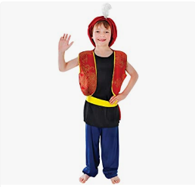
Guards something similar but all black

Sheiks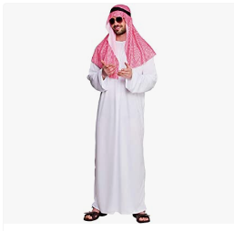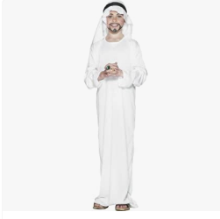
Dusty and Sandy – same as the sheiks with a bright Hawaiian style shirt over the top

BooBoo the monkey – Brown clothes, ears and a tail

